Variables in JavaScript: https://drive.google.com/drive/folders/1nweZ9gZBRqqgPfdPCLJbJPrfuAARV_8e
Variables are used to store the data.
- In JavaScript the variables are declared using three 3 keywords.
  - Var
  - let
  - const
var: The var keyword is used to declare a variable. It has a function-scoped or globally-scoped behaviour.
let: The let keyword is introduced in ES6, has block scope and cannot be re-declared in the same scope.
const: The const keyword declares variables that cannot be reassigned and update. It's block-scoped as well.

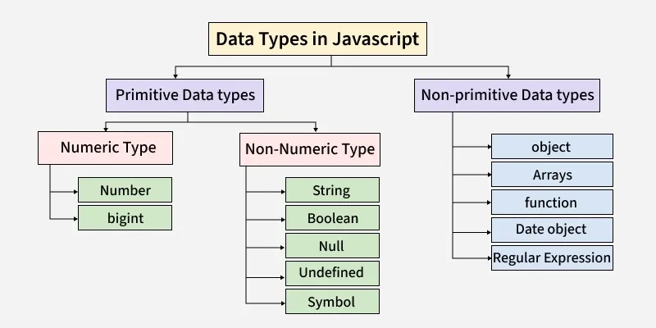

1.mutable: Mutable means the value can be changed after it is created.
2.immutable: Non-mutable (immutable) means the value cannot be changed after creation.

Mutable datatypes:
1.arrays
2.objects
3.functions

Immutable datatypes:
- Number
- String
- Boolean
- Null
- Undefined
- Symbol
- BigInt

Primitive Data Types
- Primitive types store single, immutable values.

- Number: Used for both integers and decimals.
- String : Text data written inside quotes.
- Boolean : Represents true or false.
- Undefined : A variable declared but not assigned a value.
- Null : Represents an intentional empty value.
- Bigint : Used for very large integers.
- Symbol : Used to create unique identifiers.
Non- Primitive Data Types
- These can store multiple values and are mutable.
- Object : Stores data in key–value pairs.
- Array : Used to store multiple values.
- Function: A block of reusable code.

- typeof operator: Used to check the data type.

